Name: Maira Malik

Reg.no: 2023-BSE-040

Subject: Cloud Computing

**Assignment # 1**

**Task 1:**

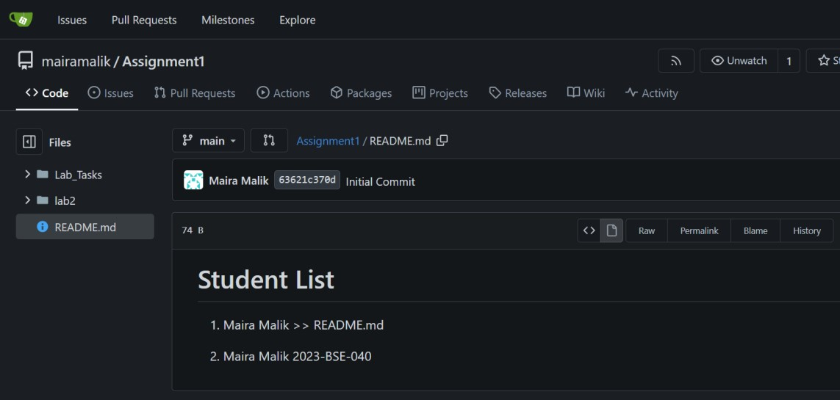

**Task 2:**

**Assignment 1 Repo link:** <https://github.com/Maira222/Assignment1>**Task 3:**

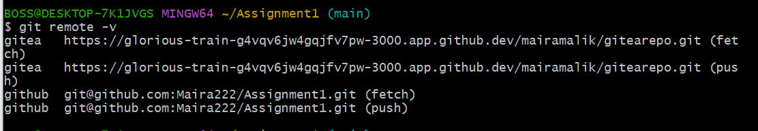

**Task 4:**

**CV/Portfolio pages link:**

<https://maira222.github.io/mairamalik.github.io/>